Pace Name______________________________________
Honors English 9 Date__________________________________
Block_____
Antigone &The Odyssey Vocabulary Words - KEY
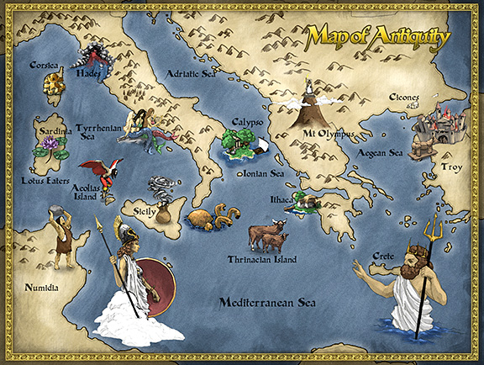
Images found at: http://www.reallycoolblog.com/wp-content/uploads/2012/11/odyssey_map.jpg

Directions: For each term below, write the definition, being sure to paraphrase the meaning into your own words. List the part of speech for each word. Use the word in an original sentence. This sentence should contain context clues in which you clearly prove you understand the meaning of the word and how it is typically used in our colloquial language.

Example:

Bravado (N) - a bold manner or a show of boldness intended to impress or intimidate
Henry’s false bravado became apparent as he cowered behind his girlfriend as they crept through the haunted house.

- Havoc (N) – great destruction
Hurricane Katrina wreaked havoc along the Gulf coast from central Florida to Texas; the most significant number of deaths occurred in New Orleans, Louisiana, which flooded as the levee system catastrophically failed.

- Meritorious (ADJ) – praiseworthy; commendable; deserving of reward
The school resource officer received a standing ovation from the students and staff as he entered the auditorium; his meritorious decisions helped save many lives during the school shooting.

- Impasse (N) - a situation in which no progress is possible, especially because of disagreement; a deadlock
The warring husband and wife had reached an impasse; neither could come to an amiable agreement about the placement of their children.

- Ingenious (ADJ) – resourceful; original and creative
The ingenious plan was not something that had spontaneously come to be; rather, the team’s inventive strategy had been years in the making.

- (to) buffet (V) – a blow with the hand or fist; to hit repeatedly
The strong, gusty ocean winds buffeted the beach house, causing it to sway on its stilts.

- Libations (N) – a pouring out of wine or other liquid in honor of a deity; alcohol
A libation is a ritual pouring of a liquid as an offering to a god or spirit or in memory of those who have died. It was common in many religions of antiquity and continues to be offered in various cultures today.

- Gall (ADJ) – audacity; shamelessness; excessive confidence or boldness
After showing up late to every meeting this year, Susan had the gall to chastise Karen for being tardy to school on Wednesday.

- Edict (N) – an official order or proclamation issued by a person in authority
Creon’s insensitive edict and his unyielding hubris led to his eventual downfall.

- Retribution (N) – punishment for wrong doing
Jodie hated having to eat lunch in the “detention” area, but she had been late to class four times, so she wasn’t surprised by the teacher’s retribution.

- Insolence (N) – rude and disrespectful behavior
Mark’s insolence cost him the ability to use the family car on Saturday night. His disrespectful attitude meant he would be catching a ride rather than giving one.

- Impiety (N) – lack of reverence, especially for a god; lack of respect
Keeping our mother’s ashes in the urn, instead of scattering them as she requested, would be impious (adj) and disrespectful to her memory.

- Consecrate (V) – to declare as sacred; to devote or dedicate to some purpose
Melissa’s life was consecrated to the raising of her four children. She gave up a wonderful career to spend every day with her family.

- Blithe (ADJ) – joyful, cheerful in disposition; carefree; happy-go-lucky
Heidi had always been a free spirit, but sometimes her blithe indifference to other’s feelings caused people to perceive her as egotistical.

- Staunch (ADJ) - characterized by firmness, steadfastness, or loyalty
Donald Trump’s staunch political views appeals to many Americans, while simultaneously offending others.

- Degenerate (ADJ) - having sunk to a condition below that which is normal to a type; especially : having sunk to a lower and usually corrupt and vicious state; (N) – a immoral or corrupt person; (V) - to fall below a normal or desirable state, especially functionally or morally; deteriorate
Degenerate clergy members reigned supreme during the Middle Ages. It was a common occurrence for a priest, friar, or monk to accept money in order to absolve people of their sins.

- Brazen (ADJ) – shameless; imprudent; defiantly bold
The assistant coach’s brazen decisions resulted in his dismissal by the head coach and team owner.

- Delude (V) – to mislead the mind; to deceive; to fool; to hoodwink
Margie’s delusional (adj) feelings for Alexander were certainly going to lead to her own heartbreak. He had made it perfectly clear that he was not interested in her.

- Defilement (N) – to debase the pureness of; to corrupt; to make filthy or dirty
The mean girls tried to defile (v) Miranda’s reputation by spreading vicious rumors about her
and several members of the football team.
- Revile (V) – to attack with abusive language; to berate
The young clerk was reviled by the drunken couple when he wouldn’t allow them to buy more alcohol.

- Transgress (V) - an act that goes against a law, rule, or code of conduct; an offense
President Snow wants to eliminate Katniss Everdeen and her followers for their transgressions (n) against the Capitol.

- Augury (N) – a sign of what will happen in the future; an omen
A yearbook augury predicted James would be the most successful of the Class of 2005.

- Pomp (N) – a show of magnificence; the impressive decorations, music, clothing etc., that are part of some formal events; a show of wealth and splendor
The pomp of Mardi Gras is legendary, with the risqué behavior of visitors, garish costumes, and loud parades.

- Invocation (N) – a prayer; the act of asking for help or support especially from a god
Homer opens his epic poem, The Odyssey, with an invocation to Calliope, the Muse of poetry, asking that she grant him the ability to skillfully and articulately tell his story.

- Unbridled (ADJ) – uncontrolled; unrestrained; done, felt, or expressed in a free and uncontrolled way
Mr. Rayman has an unbridled love for his profession, which is evident in his enthusiasm in the classroom.

- Formidable (ADJ) – deserving serious attention and respect; tending to inspire awe or wonder; to cause fear or dread
Poseidon proves to be a formidable foe to Odysseus during his journey home from the Trojan War.

